|  |  |
| --- | --- |
| cetlogo ***CHEMICAL ENGINEERING TRANSACTIONS***  ***VOL. xxx, 2025*** | A publication of  aidiclogo_grande |
| The Italian Association  of Chemical Engineering  Online at www.cetjournal.it |
| Guest Editors: Fabrizio Bezzo, Flavio Manenti, Gabriele Pannocchia, Almerinda di Benedetto  Copyright © 2025, AIDIC Servizi S.r.l. **ISBN** 979-12-81206-17-5; **ISSN** 2283-9216 | |

Quantification of triboelectric charging of a polypropylene-based powder during wall friction shear tests

Rahutosh Ranjan\*, Sina Zinatlou Ajabshir, Diego Barletta, and Massimo Poletto

Department of Industrial Engineering, University of Salerno, Italy

[rranjan@unisa.it](mailto:rranjan@unisa.it)

The phenomena of triboelectric charging, which occur unintentionally while handling powders, have been thoroughly investigated in several works reported in the literature. However, little is known about how wall friction in shear action affects powder tribocharging. This study examines the effects of friction on the tribocharging of a polypropylene-based powder during the shearing on a lid made out of a wall coupon, with particular focus on the influence of the shear cell and lid materials, particularly polylactic acid (PLA) polymer and metal. The results show that the triboelectric charge produced by shearing the powder inside a PLA cell is similar for a metal lid and a polytetrafluoroethylene (PTFE) lid, with values of about 20.03 nC and 21.5 nC, respectively. On the other hand, the triboelectric charge produced by a metal cell with a metal lid is polarity-opposite to the charge created by a PTFE lid on the identical metal cell. In particular, a charge of 16.71 nC was recorded with the metal lid and -12.4 nC with the PTFE lid.

* 1. Introduction

During powder handling activities, particles often interact with each other and with the walls of the processing equipment, resulting in tribo-electrification or tribocharging (Šupuk et al., 2009). Since uncontrolled charge accumulation could lead to operational problems, understanding charging phenomena in powder handling processes is crucial for both industrial safety and operational effectiveness (Biegaj et al., 2017). In pneumatic Conveying, problems such as dust explosion, powder separation, agglomeration and particle adherence have been reported, while unwanted charging of insulating materials can cause explosion, fire or electronic circuit damage (Mouhoub et al., 2023). Recent research has shown that tribocharging in powders occurs due to electron, ion exchange, and material transfer, which are frequently caused by friction, an extremely common phenomenon in mechanical contact and sliding (Burgo and Erdemir, 2014). Investigations by Šupuk et al. (2007) and Pingali et al. (2009) independently established the effect of shear deformation on the triboelectric charge of powders. Šupuk et al. (2007) found a positive correlation between applied shear strain and particle charge in bulk powders. The work by Pingali et al. (2010) also showed that shear affects both the electrostatic and flow characteristics of pharmaceutical powders. Karner et al. (2014) investigated the effect of particle shape, surface roughness on triboelectric charging during aerosolisation in dry powder inhalers. Luo et al. (2021) investigated the connection between the tribological behaviour of a metal and polymer friction pair and the accumulation of charges, based on the measurement of the surface potential and the coefficient of friction. Armitage et al. (2022) investigated the effects of friction and material wear mechanisms on the buildup and release of triboelectric contact charge. It is still partially understood how friction affects the triboelectric charging behaviour of powders. In particular, the tribocharging of powders undergoing quasi-static shear flow in a dense state is the subject of very few studies.

The primary focus of this work is to investigate the tribocharging characteristics of bulk powder under wall friction shear testing. The effect of the polymeric vs. metal materials on the triboelectric effect was studied.

* 1. Experimental setup and procedure

2.1 Material

A polypropylene-based powder (Ultrasint® PP nat 01, BASF), referred to as PP powder from here on, was used in this study. Its characteristics are shown in Table 1. The study aims to examine how shear stress affects triboelectric charge formation. The polypropylene-based powder sample is refreshed after each repetition of the experiment. Utilising an entirely fresh sample for each investigation aims to limit the effect of residual charge on the powder that may result from previous charge accumulation and ensures that the findings accurately reflect the material's intrinsic triboelectric properties and are not impacted by previous charges. This approach increases the repeatability and accuracy of the experimental data, providing a better understanding of the tribocharging behaviour of the PP powder.

Table 1 Polypropylene-based powder properties

|  |  |  |  |  |  |  |  |  |  |
| --- | --- | --- | --- | --- | --- | --- | --- | --- | --- |
| Tmelting [°C] | ρB [kg/m3] | ρP [kg/m3] | d10 [μm] | d50 [μm] | d90 [μm] | d2,3 [μm] | d3,4 [μm] | span | SSA [m2/g] |
| 140 | 330 | 890 | 35 | 69 | 122 | 36 | 74 | 1.26 | 0.168 |

Before starting of the experiments, the powders utilized in this investigation had a certain amount of residual charge. This charge—also known as the initially generated charge—was brought on by friction between the powder and the container's surface. The initial generated charge on the sample was determined by emptying the powder sample from the container into a Faraday cup with a wooden spoon.

2.2 Experimental setup

An Anton Paar powder shear cell installed on a Modular Compact Rheometer (MCR) is used to shear the powder over a wall coupon, as shown in Figure 1a. The shear cell device consists of a trough and an annular lid which a wall coupon is assembled to in case of a wall friction shear test. The cell trough is an annular container with an internal diameter of 19 mm, an external diameter of 45 mm, and a height of 21.8 mm. The trough cell is initially filled with powder employing a metallic workbench (Figure1e). The workbench has a revolving blade for levelling the powder surface. A perforated disk supported by a stem attached to the rheometer bench holds up the trough. The trough holds the powder sample during the tests, while the lid compresses it under an applied load. The sample is subsequently compressed vertically during the rotation of the lid relative to the cell, and the shear stress is derived by measuring the torque, allowing quantification of the wall friction between powder and lid by plotting the shear stress as a function of the normal stress.

In this study, two types of shear cell troughs were used: the standard stainless steel cell and a custom-made cell of 3D-printed polylactic acid (PLA) (Figure 1b I and II). The goal of employing two separate cell troughs is to better understand the process of triboelectric charging in both cells. Because the metallic cell is conductive, it can dissipate some of the electric charge formed during wall friction. Differently, the 3D-printed PLA cell has a high resistance to electric conduction, which restricts the movement of the created electric charge. Two types of annular wall coupon, shown in Figure 1b (III and IV), can be assembled on the lid to represent the wall. One is made of stainless steel, and the other is made of polytetrafluoroethylene (PTFE). Wooden tongs are used to lift the shear cell trough filled with the powder sample after the test and transfer them into the Faraday cup.

The initial and final electric charge of the powder is measured using a Faraday cup (Monroe model 284-284/22B), before and after shearing (Figure 1(c)). It is made up of two PTFE spacers that separate the two stainless steel cups. As shown in Figure 1(c), the outer cup is grounded, and the inner cup is connected to an electrometer Monroe Electronics Model 284 Nanocoulomb Meter via a BNC cable.

2.3. Experimental procedure

The experiment aims to measure the electric charges produced on the powder surface while shearing on a wall coupon using the Anton Paar shear cell device. The trough cells are loaded with the PP powder sample and kept on the device stand for shearing. Before testing, the electrostatic charges on the powder's surface are eliminated using an ionizing air gun (Figure 1d). The shear tester is used to apply a sequence preshear and shear on powder under normal stress of 2 kPa and 1.2 kPa, respectively, as shown in Figure 2. The sheared powder is then poured into a Faraday cup connected to the electrometer to measure the electric charge produced during the shearing process.

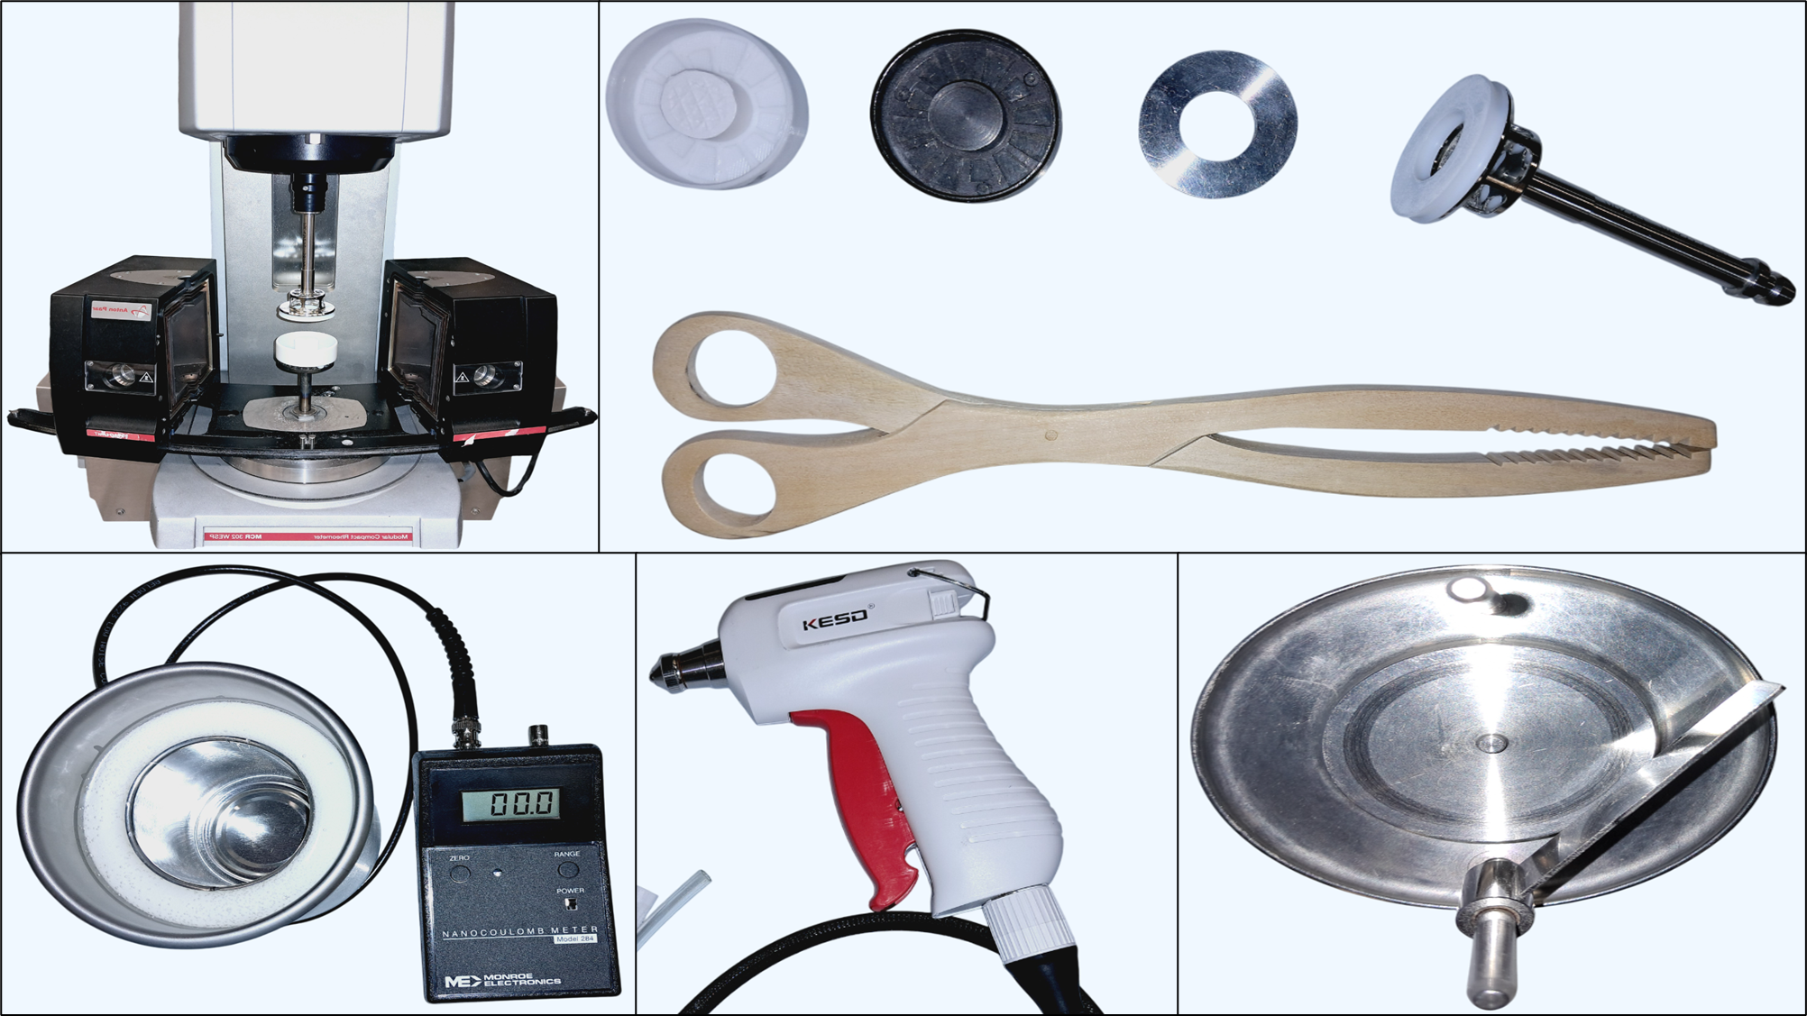

**c**

**e**

**d**

**V**

**I**

**II**

**III**

**IV**

**b**

**a**

Figure 1: (a) Cell on the Anton Paar MCR rheometer equipped with an oven, (b) (I) PLA through, (II) metal trough, (III) metal lid, (IV) PTFE lid, and (V) wooden tong; (c) Faraday cup and nanocoulomb meter, (d) ionizing air gun, (e) cell filling bench

* 1. Results and discussion

3.1. Measuring the triboelectric charges generated during the preparation of the cell

As previously mentioned, there might exist initial electric charges on the powder before conducting the experimental procedures. Moreover, electric charge can be produced during the shear cell filling preparation process on the metal workpiece because of the contact friction between the powder and the revolving blade. In the shear cell trough, the powder surface gets smoothed using the workpiece's rotating blade (Figure 1e). Therefore, it is essential to measure the triboelectric charging produced during cell preparation to observe the charge dynamics before the shearing process. The temperature during the testing was between 22.8 and 23.8°C, and the relative humidity ranged between 45 and 49.5%.



*Figure 2: The wall friction shear process.*

Two different methodologies make up the experimental methodology used in this investigation. The first method was to quantify the electric charge soon after the cell trough was prepared. A first evaluation of the surface charge produced on the PP powder was given by this measurement. The second method focused on assessing how an ionising air gun could affect the neutralisation of the generated surface charges after preparing the cell trough. This dual methodology enables a comprehensive understanding of both the initial triboelectric charging process and the following effects of ion irradiation on charge neutralisation. Results are reported in the plots of Figure 3 and Figure 4 **.**



**a)**

**b)**

Figure 3: Effect of ionising air gun on electric charge generated during the preparation of the: (a) plastic cell and (b) metal cell.

Inspection of Figure 3 makes evident that the accumulated electric charge on the prepared cells decreases when the ionising air gun is used on them for increasing time. This result suggests that the ionised air can effectively neutralize the surface charges generated during the triboelectric charging process. However, it can be seen from Figures 3a and 3b that the effect of the ionising air gun is more significant in the case of the PLA trough cell compared to the metal cell. Histograms in Figure 4 further confirm the electric charge reduction during the preparation of the cell, despite residual charges being measured after the ionization as well. The reduction in electric charge points to a possible strategy for reducing the electric charge before the shearing experiment. As a result, in the following experiments, the ionizing air gun was used to deionize the shear cell trough for two minutes to reduce accidental electric charges.

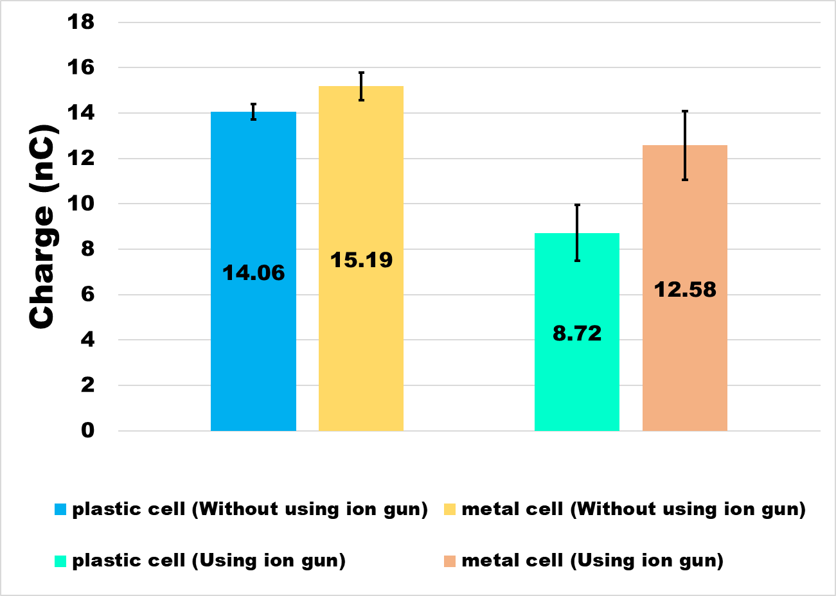

Figure 4: Electric charge generated on PP powder during the preparation of the cell.

3.2. Triboelectric charging due to wall friction on a PTFE lid

The wall friction tests for tribocharging were carried out at room conditions on a PP powder sample as it was and on a powder sample after drying at 100 °C overnight to remove moisture. This procedure was applied for both PLA and metallic cells. After completing the preshear and shear steps over a PTFE lid, only the powder sample was transferred into the Faraday cup connected to the electrometer. After the test, the electric charge measured for the PLA cell with untreated powder was 11.83 nC, whereas for the metal cell trough was -8.21 nC, as shown in Figure 5a. This highlighted that the polarity of the electric charge had changed after the shearing of the PP powder in the metallic cell. In fact, positive electric charges were measured after the preparation of the powder sample in a metal cell.

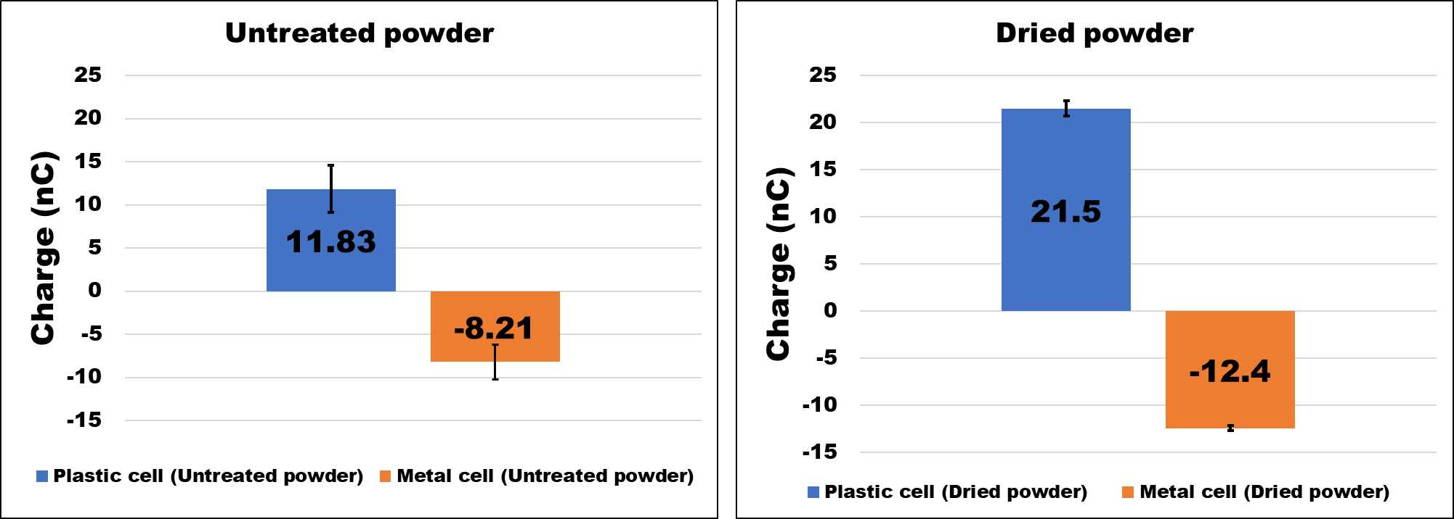

a)

b)

Figure 5: Electric charge generation by shearing on a PTFE lid: a) untreated powder and b) dried powder.

The effect of moisture removal from the powder by drying on triboelectric charging can be observed by comparing plots in Figures 5a and 5b. The comparison reveals a significant rise in electric charge after removing moisture from the powder. The electric charge for the plastic cell almost doubled varying from 11.83 nC to 21.5 nC, whereas the electric charge for the metal cell changed from -8.21 nC to -12.4 nC.

This rise in electric charge can be explained by considering that moisture content in the powder could improve the mobility of the created electric charges between particles and the cell wall. In high moisture conditions, charges migrate out from the cells more easily, resulting in lower measured electric charge values (Beretta et al., 2020). As a result, the drying process is crucial for optimising the materials' electrostatic properties since it increases charge retention for triboelectric effects.

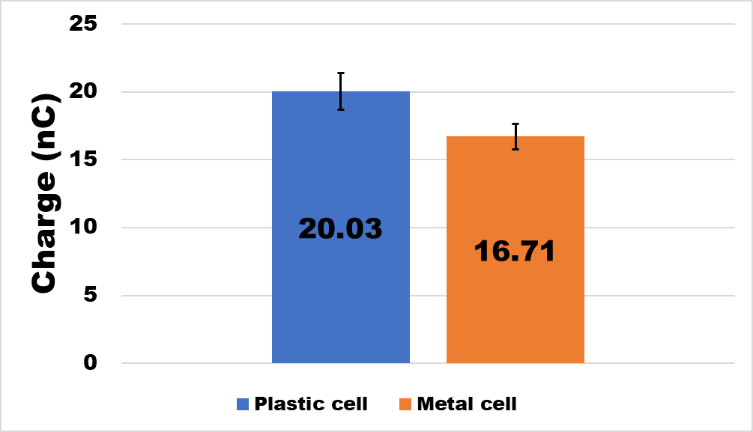

Figure 6: Electric charge generation by shearing on a metal lid.

3.3. Triboelectric charging due to wall friction on a metal lid

Additional shear tests were performed to determine the electric charge created by friction on a metal lid while keeping the experimental procedure consistent. The purpose of this extra test is to determine how a more electrically conductive metal lid affects the triboelectric charging properties of the PP powder. The study aims to establish if variations in material composition influence the formation and buildup of electric charge during shear. The findings of these shear tests performed in the PLA cell with a dried powder sample revealed that the electric charge created by the metal lid was almost the same as that generated by the PTFE lid, as can be noticed by comparing the plots in Figure 5b and Figure 6. Instead, the charge of powders sheared in a metallic cell was positive with the metallic lid and negative with the PTFE lid. Possible explanations for this discrepancy might be sought in the electrically conductive properties of the metal lid, which deserve further studies.

* 1. Conclusions

In conclusion, the investigation of triboelectric charging characteristics during the shearing of a polypropylene-based powder on metal and PTFE lids using both metal and plastic cells revealed significant insights. Preliminary tests showed the importance of neutralising electric charges accidentally generated during the powder sample preparation. Care must be devoted to this step to obtain consistent and accurate charge measurements after shearing the powder. Experimental results demonstrated that the presence of moisture in the powder sample substantially influenced the electric charge generation, with higher moisture levels leading to lower triboelectric charging. Furthermore, the use of different cell materials and lids influenced the sign and magnitude of the electric charge. The electric charging appeared to be more sensitive to the material of the cell than to the material of the wall lid. In particular, the largest difference in the value of the electric charge was observed by coupling the metallic with the metallic lid and the metallic cell with the PTFE lid. Further studies are necessary to shed light on this issue. Overall, the experimental findings emphasize the importance of considering environmental factors and material composition to understand and control triboelectric charging phenomena, offering valuable insights for optimizing the handling and processing of polymeric powders in various applications.

* 1. Acknowledgements

This work was supported by the Italian Ministry of University and Research with the PRIN PNRR 2022 grant P2022H7YCK.

References

Armitage J.L., Ghanbarzadeh A. , Bryant M. G., Neville A., 2022, Investigating the Influence of Friction and Material Wear on Triboelectric Charge Transfer in Metal–Polymer Contacts. Tribology Letters 70, 1–17.

Beretta M., Hörmann T.R., Hainz P., Hsiao W.K., Paudel A., 2020, Investigation into Powder Tribo-Charging of Pharmaceuticals. Part I: Process-Induced Charge via Twin-Screw Feeding. International Journal of Pharmaceutics 591 120014.

Biegaj K.W., Rowland M.G., Lukas T.M., Heng J.Y.Y., 2017. Surface Chemistry and Humidity in Powder Electrostatics: A Comparative Study between Tribocharging and Corona Discharge. ACS Omega 2, 1576–82.

Burgo T.A.L., Erdemir A., 2014, Bipolar Tribocharging Signal During Friction Force Fluctuations at Metal–Insulator Interfaces. Angewandte Chemie 126, 12297–12301.

Karner S., Littringer E.M., Urbanetz N.A., 2014, Triboelectrics: The Influence of Particle Surface Roughness and Shape on Charge Acquisition during Aerosolization and the DPI Performance. Powder Technol. 262, 22–29.

Luo N., Feng Y., Zhang L., Sun W., Wang D., Sun X., Zhou F., Liu W., 2021, Controlling the Tribological Behavior at the Friction Interface by Regulating the Triboelectrification. Nano Energy 87, 106183.

Mouhoub S., Kachi M., Zouzou N., 2023, Influence of the Initial Charge on the Triboelectrification of Millimeter Size Set of Particles in an Inclined Tube. Powder Technol. 428, 118862.

Pingali K.C., Tomassone M.S., Muzzio F.J., 2010, Effects of Shear and Electrical Properties on Flow Characteristics of Pharmaceutical Blends. AIChE Journal 56, 570–83.

Šupuk E., Antony J., Seiler C., Ghadiri M., 2007, Electrostatic Charge Generation Due to Shear Deformation of Pharmaceutical Powders. in: PARTEC 2007, 27 March - 29 March 2007, Nuremberg, Germany.

Šupuk E., Seiler C., Ghadiri M., 2009, Analysis of a Simple Test Device for Tribo‐Electric Charging of Bulk Powders. Particle & Particle Systems Characterization 26, 7–16.